Q. Create table employee and Insert Value.
QUERIES:
CREATE TABLE employee (
emp_id INT PRIMARY KEY,
emp_name VARCHAR(50),
emp_salary DECIMAL(10,2)
);

INSERT INTO employee (emp_id, emp_name, emp_salary) VALUES
(101, 'Aarav', 55000),
(102, 'Diya', 72000),
(103, 'Kabir', 55000),
(104, 'Meera', 90000),
(105, 'Rohan', 68000),
(106, 'Ananya', 72000),
(107, 'Vivaan', 48000),
(108, 'Ishita', 90000),
(109, 'Aditya', 61000),
(110, 'Sneha', 68000);

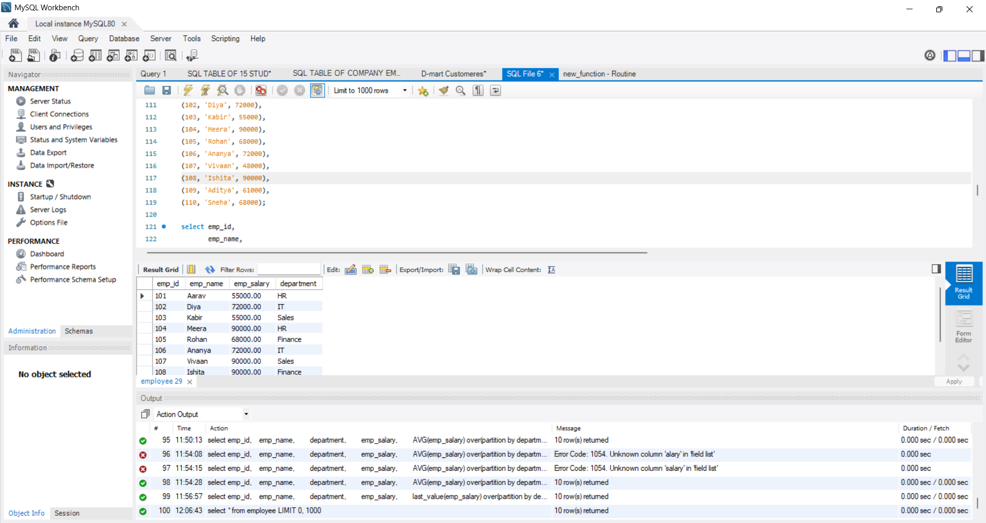

Insight:
Created employee table with 10 rows

Q. ROW NUMBER
SELECT STUD_ID,
STUD_NAME,
GPA,
ROW NUMBER() OVER(ORDER BY GPA DESC) AS GPARANK FROM STUDENT;
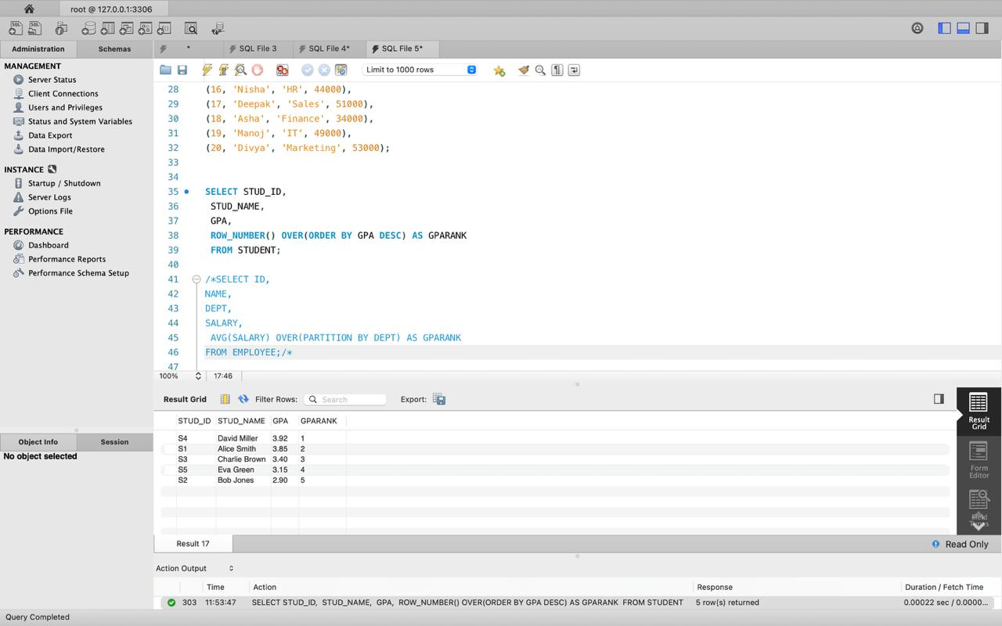
Insights:
Rank according to no. of rows

Q. DENSE RANK
SELECT ID
NAME,
DEPT,
DENSE RANK() OVER (PARTITION BY DEPT ORDER BY SALARY DE FROM EMPLOYEE:

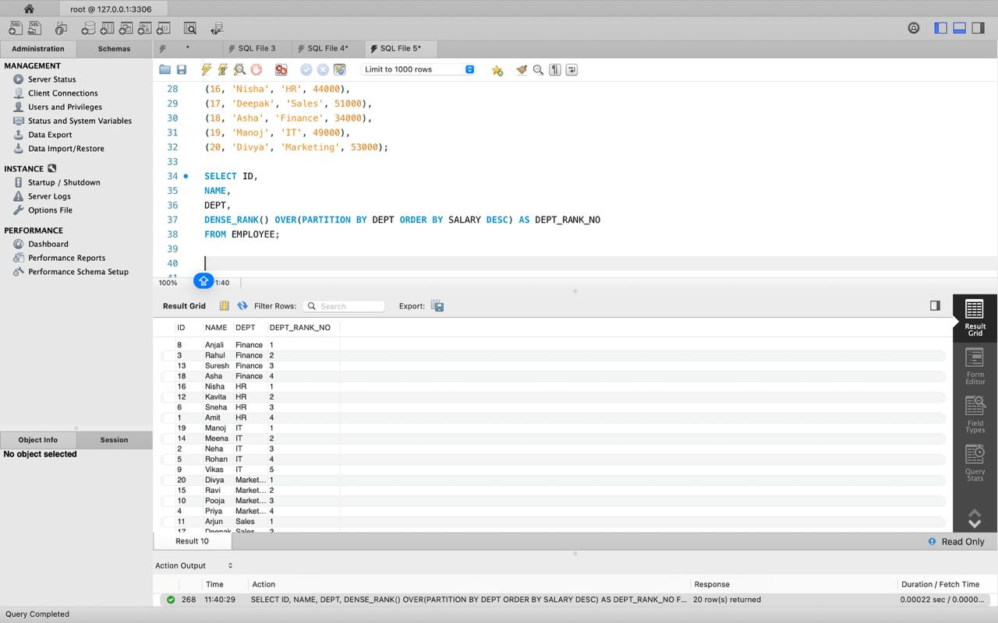
INSIGHT:
More specific ranks of students using GPA.

Q. GPA RANK
QUERIES:
SELECT STUD ID,
STUD_NAME,
GPA,
ROW NUMBER() OVER(ORDER BY GPA DESC) AS GPARANK
FROM STUDENT



Insight:
Rank of students according to GPA.

Q. SUM of salaries of employee
QUERIES:
select emp_id,
emp_name,
department,
emp_salary,
SUM(emp_salary) over(partition by department) as salary_rank
from employee;
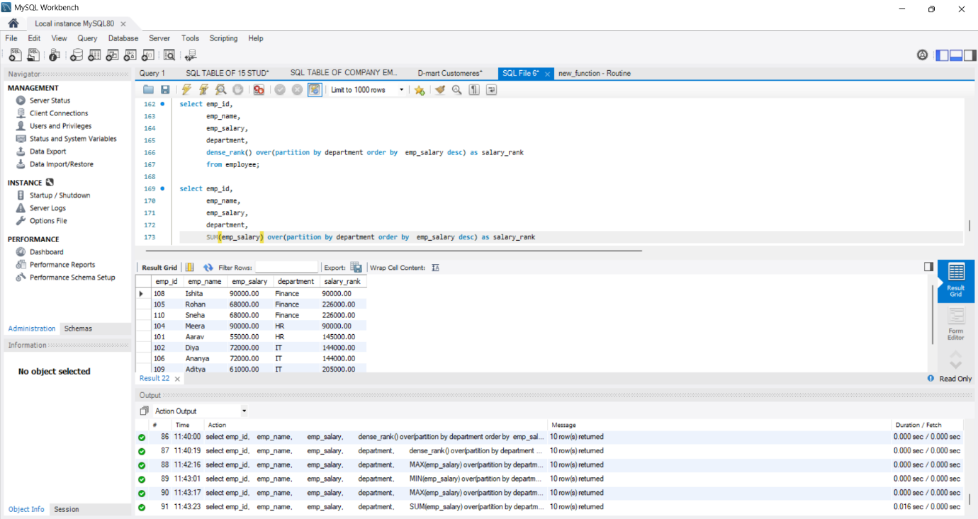
Insight:
sum of salaries of employies in department

Q. MAX salary in Department
QUERIES:
select emp_id,
emp_name,
department,
emp_salary,
MAX(emp_salary) over(partition by department) as salary_rank
from employee;
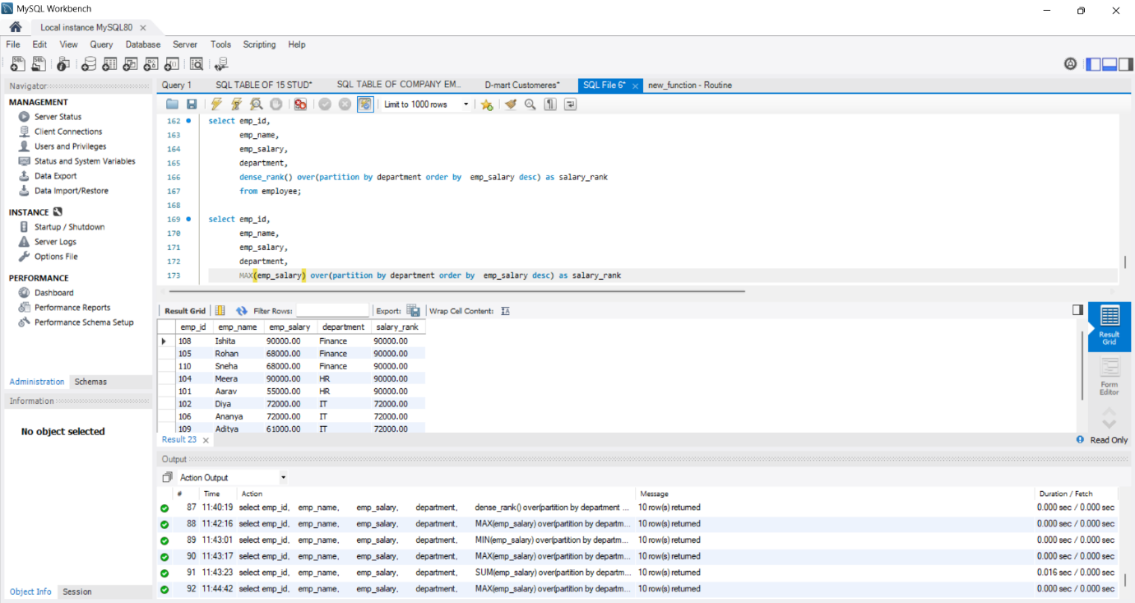
Insight:
Maximum salary of employee in department

Q. MIN Salary of employess
QUERIES:
select emp_id,
emp_name,
department,
emp_salary,
MIN(emp_salary) over(partition by department) as salary_rank
from employee;
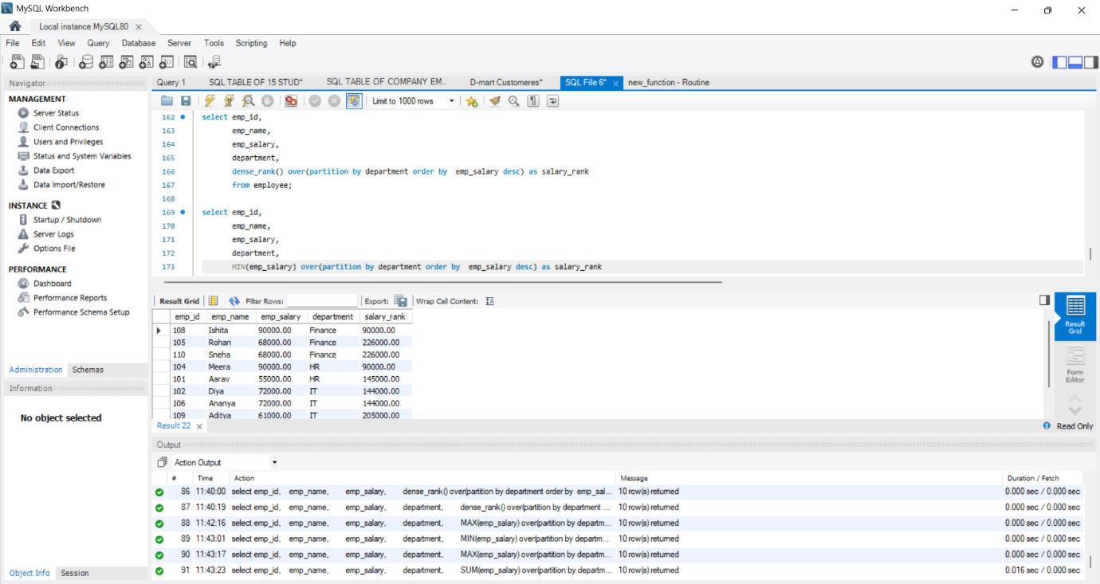

INSIGHT:
Minimum salary of employee in department

Q. AVG salary of employee and difference between avg and actual salary
QUERIES:
select emp_id,
emp_name,
department,
emp_salary,
AVG(emp_salary) over(partition by department) as salary_rank,
emp_salary - AVG(emp_salary) over(partition by department) as salary_rank

from employee;
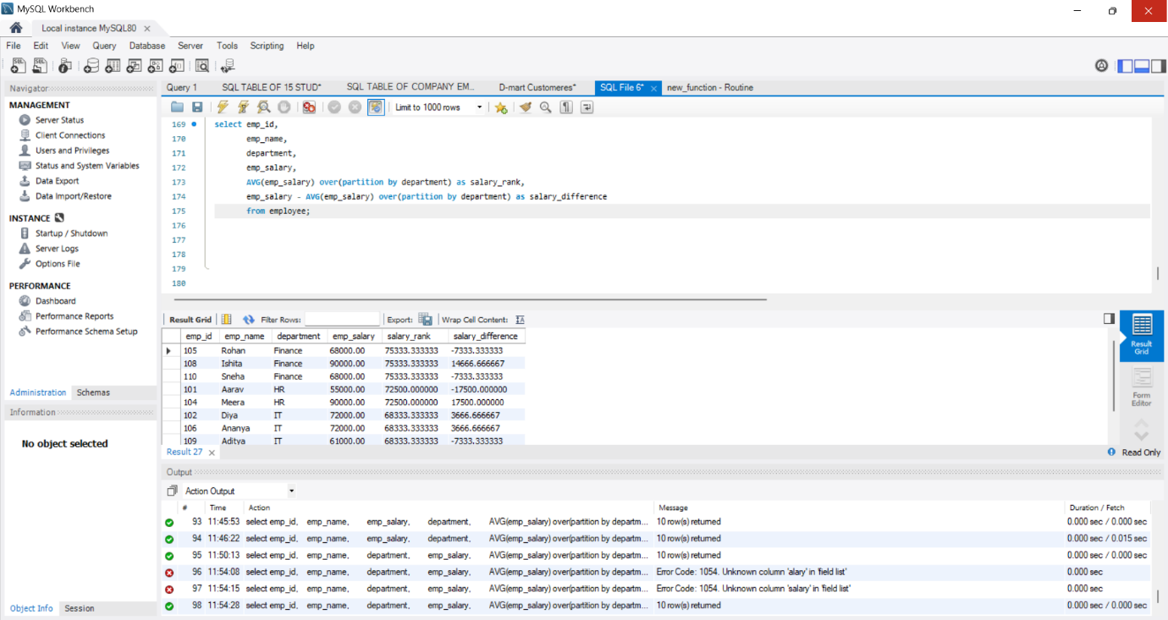
INSIGHT:
In this we got difference between average salary of department and employees salary

